Name:__________________________________ Period:_________ Date:_____________
IS2 Semester 2 Final Review – Due Wednesday June 7 EOP
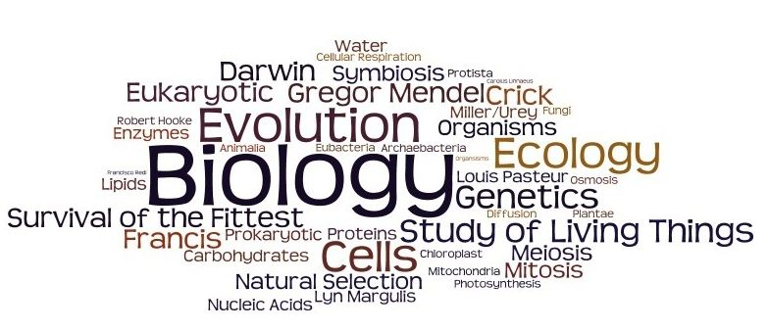
About the Final:
- 100 Multiple choice questions
- Final will be cumulative of last semester + science practices
- Covers Genetics/Molecular Bio/Ecology & Experimental design Units-
- 88 minutes-
- Final Exam- periods 4 Monday, June 11
Inquiry/Experimental Design
Major Concepts from Chapter 1:
- Be able to explain the process of scientific inquiry
Learner Engages in Scientifically Oriented Questions.
Learner Gives Priority to Evidence in Responding to Questions.
Learner Generates Explanations from Evidence.
Learner Connects Explanations to Scientific Knowledge.
Learner Communicates and Justifies Explanations

- Understand the difference between an inference, hypothesis, law and theory
Inferences are conclusions based on direct observation and reasoning.
- Hypotheses are tentative explanations based on evidence that are limited.
- Scientific theories are comprehensive and in-depth explanations of observed phenomenon, whereas
- laws describe these phenomenon (usually in mathematical relationships). i.e. law of gravity

- Be able to explain how to write a conclusion and interpretation for lab data
See lab rubric – restate hypothesis, provide supporting data (high/low value) and use explanatory language to connect evidence to conclusion.

- Explain what a control group is and how is used; know how this is different from the controlled variables in an experiment
The control group is defined as the group in an experiment or study that does not receive treatment by the researchers and is then used as a benchmark to measure how the other tested subjects do

- Be able to identify the key elements of a given experimental design (manipulated variable, responding, etc.)
Testable question and hypothesis
Definable MV and RV, controlled variables, experimental control (group), well thought out procedure, is both valid and reliable

- In terms of an experimental design what is the difference between reliability and validity?
Validity means that the experimental design is set up to test or answer the question investigated and that all variables are controlled except for the MV. Reliability means that the investigation can be repeated with consistent results.

Review Questions from Chapter 1:

For each experiment below, identify the manipulated variable, responding variable, control group and any controlled variables.
- A student wanted to test how the mass of a paper airplane affected the distance it would fly. Paper clips were added before each test flight. As each paper clip was added, the plane was tested to determine how far it would fly.

Manipulated variable ______mass of paperclip__________
Responding variable _____distance plane travels_____________
Control group _____paper airplane w/o paperclip____________
Controlled Variables
The same airplane design, same force applied to launch, same launch technique, same wind speed outside, etc.

- Two groups of students were tested to compare their speed working math problems. Each group was given the same problems. One group used calculators and the other group computed without calculators.

Manipulated variable: Use of calculators for making calculations

Responding variable: speed for doing math problems

Control group: group- w/o/ calculators

Controlled Variables: Same problems, same testing environment, same math background.

- Larry was told that a certain muscle cream was the newest best thing on the market and claims to double a person’s muscle power when used as part of a muscle-building workout. Interested in this product, he buys the special muscle cream and recruits Patrick and SpongeBob to help him with an experiment. Larry develops a special marshmallow weight-lifting program for Patrick and SpongeBob. He meets with them once every day for a period of 2 weeks and keeps track of their results. Before each session Patrick’s arms and back are lathered in muscle cream, while SpongeBob’s arms and back are lathered with the regular lotion. Muscle power is measured using a “Muscle O’meter.”
Time | Patrick | SpongeBob
Initial Amount | 18 | 5
After 1 wk | 24 | 9
After 2 wks | 33 | 17

Which person is in the control group? SpongeBob

What is the manipulated variable? use of muscle cream

What is the responding variable? muscle power

What should Larry’s conclusion be based on the data?
Claim of effectiveness of muscle cream is not supported by the data. Muscle power of SpongeBob more than tripled, whereas musclepower of Patrick only doubled.

Chapter 7 Review: (Genetics)
Major Concepts from Chapter 7:
- Be able to use Punnett squares to solve monohybrid and dihybrid genetic crosses- see practice problems-
- Know the similarities and differences between meiosis and mitosis. i.e. create a Venn diagram
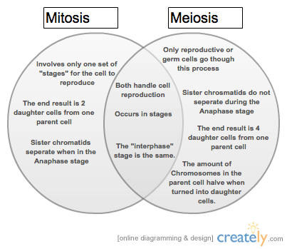
- How do mitosis and meiosis differ in terms of biological purpose/function?
Mitosis- biological function is growth, repair and asexual reproduction.
Meiosis- biological function is to produce gametes, which lead to genetic variation.
- How does the chromosome number compare in terms of parent and daughter cells in meiosis and mitosis. Use the terms diploid and haploid in your explanation.
Mitosis: parent cell is diploid and produces two daughter cells that are diploid.
Meiosis: parent cell is diploid and four daughter cells are
- Explain where genetic variation comes from.
In meiosis, genetic variation comes from crossing over, independent assortment (segregation for more than one genes) and random fertilization of gametes.
- Use the following vocab to explain a genetic cross: P generation, F1 generation, allele, genotype, phenotype, heterozygous, homozygous, dominant, and recessive sex-linked and incomplete dominance to describe traits.
P generation, Parent generation
F1 generation, First generation
allele, alternate forms of a gene
genotype, refers to the genetic makeup of an organism; in other words, it describes an organism's complete set of genes. In a more narrow sense, the term can be used to refer to the alleles, or variant forms of a gene, that are carried by an organism. (AA)
phenotype, the physical expression of a gene or genes. Red hair, Type A blood type etc.
heterozygous, A dominant and recessive allele together Aa AKA: hybrid condition
homozygous: Two of the same alleles together AA, aa
dominant: For a single dominant trait to be expressed, the dominant allele must be present (Homozygous dominant or heterozygous condition)
recessive: For a single recessive trait to be expresses, the both recessive alleles must be present (Homozygous recessive condition)
sex-linked: applies to genes that are located on the sex chromosomes. These genes are considered sex-linked because their expression and inheritance patterns differ between males and females. While sex linkage is not the same as genetic linkage, sex-linked genes can be genetically linked
incomplete dominance: is a form of intermediate inheritance in which one allele for a specific trait is not completely expressed over its paired allele. This results in a third phenotype in which the expressed physical trait is a combination of the phenotypes of both alleles. Example: red pure-breeding flowered plant crossed with a white pure-breeding flowering plant produce pink flowered plants.

Practice Problems for Chapter 7:
- Cross - Green sepals (G) is dominant over yellow sepals (g).

Parent 1 Gg X Parent 2 gg
Predicted Results
Genotypic Ratio: | Phenotypic Ratio:
1Gg:1gg | 1Green:1 Yellow

 | G | g
g | Gg | gg
g | Gg | gg

- What is the difference between homozygous genotypes and heterozygous genotypes?
- homozygous genotypes: alleles are the same (ll or LL)
- heterozygous genotypes: alleles are different (Ll)
- When are dominant traits expressed? When are recessive traits expressed?
- For a single dominant trait to be expressed, the dominant allele must be present (Homozygous dominant or heterozygous condition)
- For a single recessive trait to be expresses, the both recessive alleles must be present (Homozygous recessive condition)

- Write a Punnett square showing the following dihybrid cross between a wrinkled, heterozygous yellow pea plant and a pea plant heterozygous for both traits.
Genotypes of Parents _rrYy___ x _RrYy____
R = round seed, r = wrinkled seed
Y = yellow seed, y = green seed
Gamete combinations for both parents.
ry, rY and RY, Ry, rY and ry

b. What percentage of the offspring will be round and yellow? ___3___
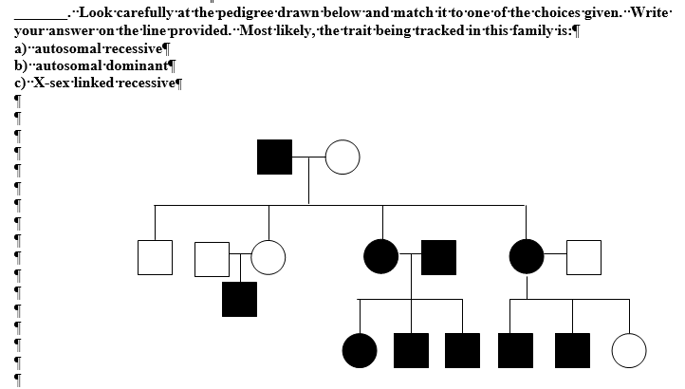
- Autosomal recessive
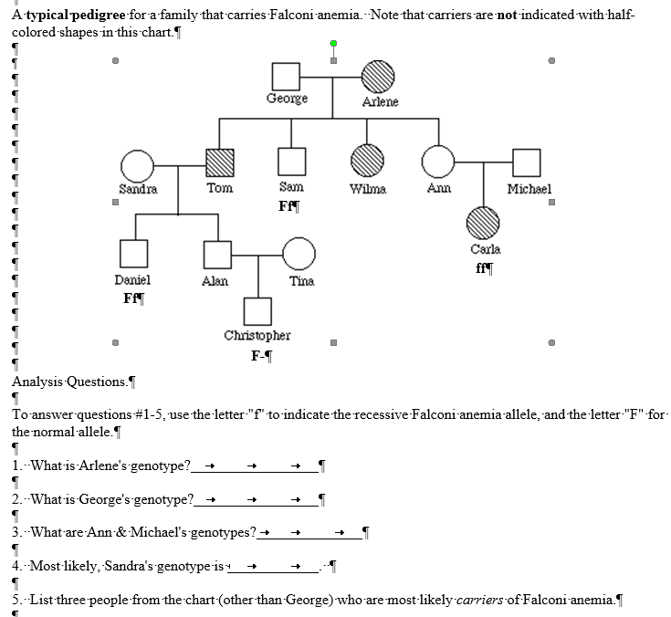
- Ff 2. Ff 3. Ff for both 4. Could be FF or Ff 5. Ann, Michael and Alan

- What types of cells are created during meiosis, haploid or diploid? Why is this important? What is the difference between haploid and diploid cells?

Meiosis: haploid gamete cells, conserves chromosome #. Haploid cells have half the number of chromosomes, whereas diploid cells have a full set of chromosomes.

- Draw the result of a cell with 3 chromosomes that underwent meiosis. Label each stage.
See diagram below
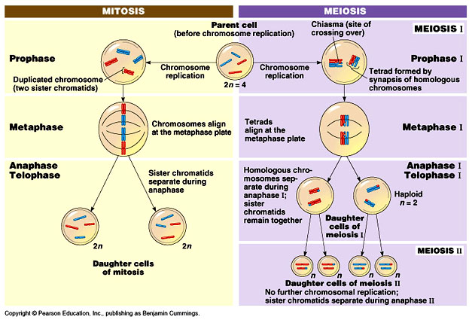
- Draw a nucleus of a cell with 3 chromosomes in each stage of mitosis below. Label each stage.
See above diagram

- What must happen before mitosis? ___DNA duplicates______

- How does meiosis increase variation in a population?
In meiosis, genetic variation comes from crossing over, independent assortment (segregation for more than one genes).
- Why is genetic variation important in a population?
It is necessary for a population to evolve.

Chapter 8 Review: (molecular biology)
Major Concepts from Chapter 8:
- Describe the structure of DNA.See below
- Compare and contrast DNA and RNA.
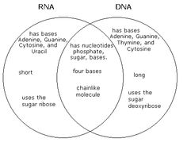
- Be able to describe the processes of transcription and translation on the way to making a protein.
- Explain how the sequence of amino acids is important in determining protein shape and function.
- Be able to describe how mutations occur in DNA and the effects that mutations have on an organism.
Review Questions from Chapter 8:
- Draw and label the overall structure of DNA (include the following terms in your diagram: double helix, nucleotide base, and hydrogen bond).
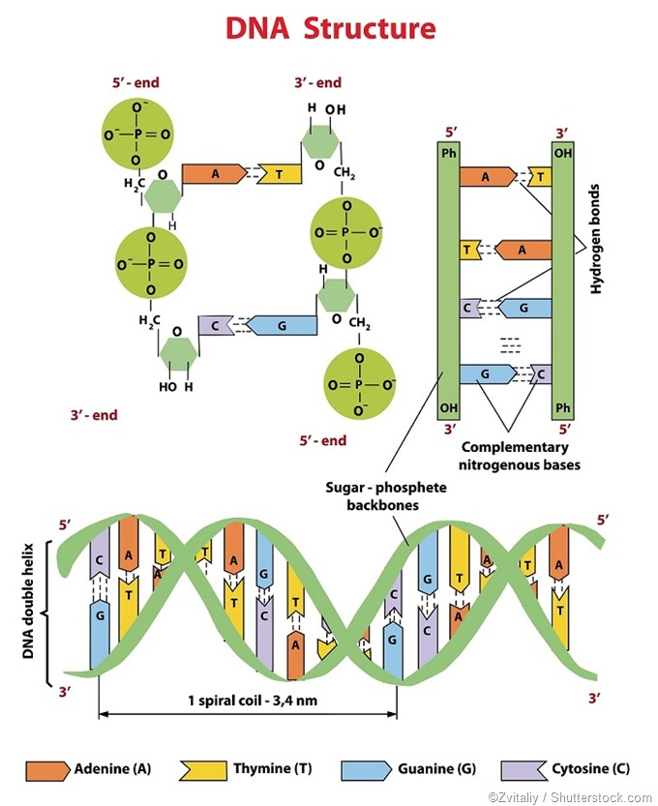
- Draw a nucleotide and label the 3 parts. (include nucleotide base, phosphate backbone, deoxyribose sugar and hydrogen bond

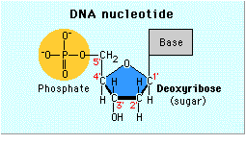
- What is the function of DNA? Where is DNA found in eukaryotic cells?
DNA carries the genetic code, It is found in the nucleus od eukaryotic cells.

- In DNA, what are the 4 different nucleotides? Which nucleotides are paired together according to Chargaff’s rules?

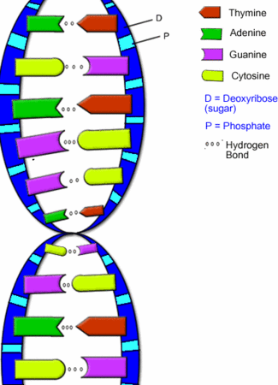

- Why is DNA replication said to be semi-conservative?
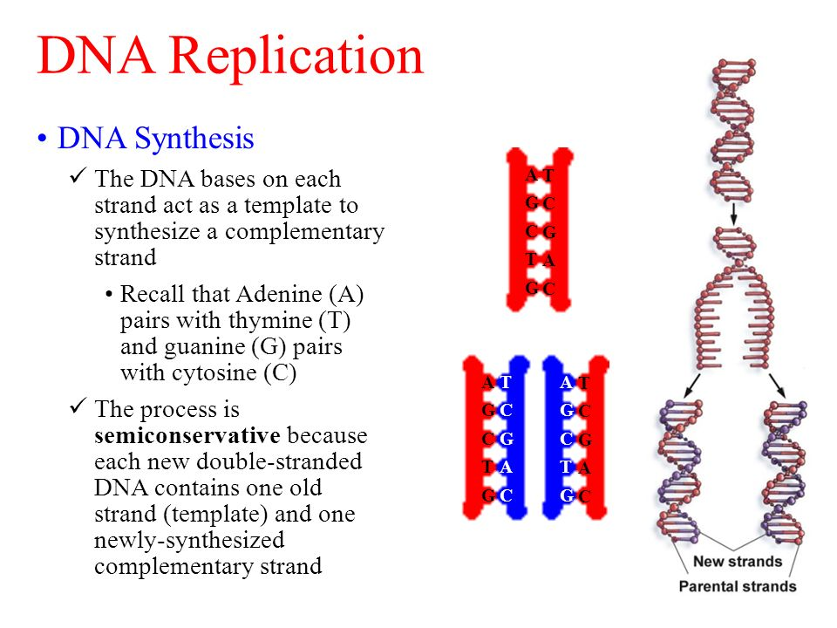
- What is meant by DNA being complimentary? If you know the nucleotide sequence of one strand of DNA you can infer the nucleotide sequence of the other strand based on Chargaff’s rules.

Show your understanding for the DNA strand below:
A T G C C C T T C A C A G A G T A G
T A C G G G A A C T G T C T C A T C
- Use a Venn diagram to compare and contrast DNA replication with protein synthesis.
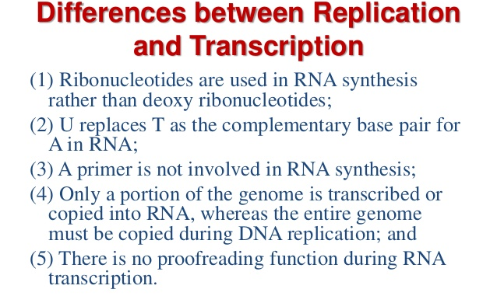
- In your own words, what is transcription? Be sure to include where it happens and the key “players” involved.
Transcription is the first step of gene expression, in which a segment of DNA is copied into RNA (especially mRNA) by the enzyme RNA polymerase. Both DNA and RNA are nucleic acids, which use base pairs of nucleotides as a complementary language.
- DNA is our genetic blueprint-so why do we need mRNA?
mRNA makes a copy of a gene and then transfers that code to the ribosome.
- In your own words what is translation? Be sure to include where it happens and include the following key vocabulary in your description.
translation is the process in which ribosomes in a cell's cytoplasm create proteins, following transcription of DNA to RNA in the cell's nucleus. The entire process is a part of gene expression.
Parts of Translation | How Translation works  (write/diagram how it happens – use the vocab words on the left)
Ribosome  mRNA  tRNA  Codon  Anti-Codon  Amino Acid  Protein | In translation, messenger RNA (mRNA) is decoded by a ribosome, outside the nucleus, to produce a specific amino acid chain, or polypeptide. The polypeptide later folds into an active protein and performs its functions in the cell. The ribosome facilitates decoding by inducing the binding of complementary tRNA anticodon sequences to mRNA codons. The tRNAs carry specific amino acids that are chained together into a polypeptide as the mRNA passes through and is "read" by the ribosome.

- What are some of the similarities and differences between DNA and mRNA?. (Venn diagram?)
See Venn diagram above.
- What is a mutation? What is the worst type of mutation? Why? What type of mutation has the least impact on an organism?

A mutation is a change in the genetic code. The worst type are frameshift resulting from an insertion or deletion in the genetic code

- What can cause a mutation?
Acquired (or somatic) mutations occur at some time during a person's life and are present only in certain cells, not in every cell in the body. These changes can be caused by environmental factors such as ultraviolet radiation from the sun, or can occur if a mistake is made as DNA copies itself during cell division.
- Why are mutations in gametes different than mutations in somatic (body) cells? (Which mutation can be transmitted across generations?
Mutations occurring in body cells are called 'somatic mutations', and (unless they occur in cells that will become ovaries or testes) they will not be passed to offspring. However, mutations can also occur in reproductive tissues - in the cells that will produce gametes (or spores) which can be transmitted across generations.

- Below is a strand of the DNA strand that is transcribed. Follow the steps of transcription and translation to determine the amino acid sequence of the protein to be made (use your DN Agent decoder):
A T G C C C T T C A C A G A G T A G
mRNA: U A C G G G A A C U G U C U C A U C
amino acid. sequence:___Tyr-Gly-Asn-Cys-Leu-ile

Chapter 14 Review: Ecology

Major Concepts from Chapter 14 (ecology):
- Explain in your own words what a limiting factor is
In ecology, common limiting factor resources are environmental conditions that limit the growth, abundance, or distribution of an organism or a population of organisms in an ecosystem.
- Provide two examples of an abiotic and two examples of biotic limiting factors for an ecosystem.
Abiotic: Nutrients can be limiting for plant/algae growth. Phosphorus is limiting in freshwater aquatic systems, nitrogen is limiting in marine systems. Light is limiting for algae growth in aquatic systems.
Biotic: Pathogens can be limiting for a population. Predation can also be limiting on a population.
- Explain what is meant by carrying capacity for an ecosystem and describe some of the factors that affect it.
The carrying capacity is the number of individuals in a population that a specific area can sustain with existing resources.
- Explain in your own words what a population is?
A group of organisms of one species that interbreed and live in the same place at the same time
- Distinguish between density-dependent factors and density-independent factors. Provide two examples of each.
The density dependent factors are factors whose effects on the size or growth of the population vary with the population density. There are many types of density dependent limiting factors such as; availability of food, predation, disease, and migration.
density-independent factor Any factor limiting the size of a population whose effect is not dependent on the number of individuals in the population. An example of such a factor is an earthquake, which will kill all members of the population regardless of whether the population is small or large, other examples are forest fires, asteroid (oh my), tsunami, flood, etc..
- Compare and contrast the movement of matter and energy in an ecosystem.
Matter cycles continuously throughout an ecosystem whereas energy flows one direction. Based on the second law of energy the quality of energy is reduced from a higher quality to a lower quality through each transformation. For example light energy is changed to chemical in plants through photosynthesis (light energy is a higher quality energy form than chemical energy, which is a higher energy form than heat).
- Interpret food webs – identify producers (autotrophs), primary, secondary, and tertiary consumers.
You did this with the last lesson on the savanna ecosystem.-

- Identify organisms in different trophic levels and predict the amount of energy in each tropic level.
You did this with the last lesson on the savanna ecosystem.-

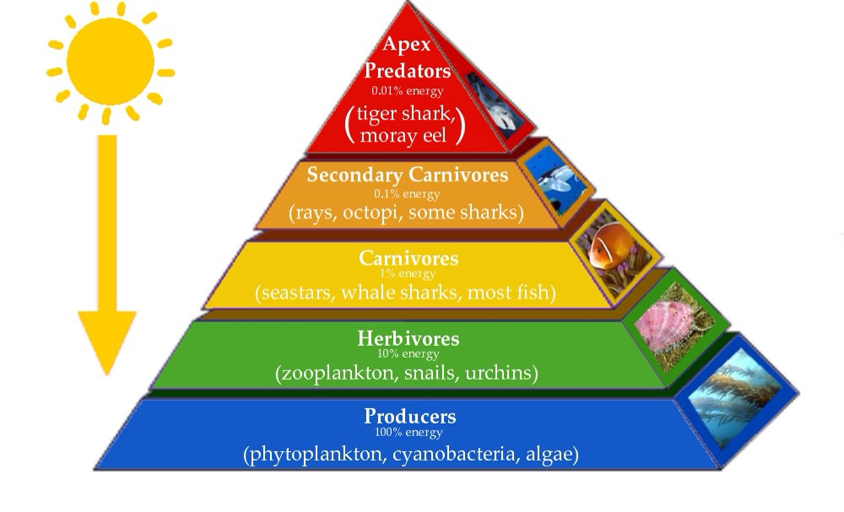
- Provide an example of the following types of species interactions. Explain why that example fits that association.
Mutualism and Symbiosis (difference?): Lichen (algae and fungus) symbiosis/clownfish and anemone mutualism/shark and remora- cleaner fish
Predator/prey: Fox and hare
Parasitism: tapeworm and human (longest one found 100” FYI)
Herbivory: deer and your geraniums
Competition: members of any population competing for same resources.

- Identify and interpret exponential vs. logistic population growth models.

- What growth model describes human population growth. What are some of the recommended ways that we can slow it down? Exponential growth-

- Be able to interpret and explain future population growth using age structure diagrams (population pyramids).

Review Questions from Chapter 14:
- Write out the equation for determining population size. (use birth rate, death rate, immigration, and emigration)

Population= (births - deaths) + (immigration-emigration)

- If an ecosystem contains 100 rabbits in an area of 20 square meters, what is the population density of the rabbits?
5 rabbits per square meter

- Give an example of a density-dependent factor that affects population size. Give an example of a density-independent factor.
Density-dependent: Environmental factors are those agents whose limiting effect become more intense as the population density increases.

Density-independent: environmental factors not effecting birth rate and death rate and do not change with population density. Flood, fire, habitat loss.

- What is an ecological niche? What is the difference between a niche and a habitat? Apply the concept of niche to explain why some invasive species thrive in an area.

The role a species plays in the ecosystem is called its niche. A habitat is the physical environment in which a species lives.

- Snails die and leave their shells behind. Hermit crabs find their shells and move in. Identify the type of species relationship illustrated.
Commensalism

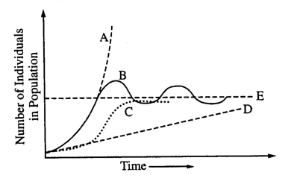
- Which letter of the graph represents:

  - Carrying Capacity:___E___

  - Logistic Growth:___C____

  - Human population growth:__A_

- Give an example of a limiting factor in an aquatic ecosystem:

Light, water temperature , oxygen, pH

- A tropical rainforest is an example of an ecosystem. Which of the following statements about matter and energy in a tropical rainforest is the most accurate? Please choose ONE answer that you think is best.
a. Energy is recycled, but matter is not recycled.
b. Matter is recycled, but energy is not recycled.
c. Both matter and energy are recycled.
d. Both matter and energy are not recycled.
- Give an example of the following species relationships in a community:
  - Mutualism
Butterfly pollinator and flower

  - Predator-prey
Lynx and hare

  - Herbivory
Elk and willow trees

  - Competition
Gray squirrel and Douglass squirrel

- Why are there typically only 4-5 links in a food chain?
Not enough energy to sustain other feeding levels (energy to obtain and process food)

- What is the difference between biotic and abiotic factors? Abiotic= not living factors: climate, water, soil,/Biotic= living. Provide an example of how an abiotic factor regulates a population. Water temperature could affect population of icefish. Provide an example of how a biotic factor regulates a population. Malaria can regulate human populations (increased mortality).

- Autotrophs
  - can live without heterotrophs.
  - cannot do photosynthesis.
  - might eat heterotrophs.
  - are known as decomposers.

Use the diagrams below to answer questions #13-14:
Diagram A
Diagram B
Ecosystem
Ecosystem
- Which diagram shows how energy moves in ecosystems? Explain your answer.
Diagram B- energy flows in one direction
- Which diagram shows how matter moves in ecosystems? Explain your answer.
Diagram A- matter cycles within an ecosystem and is reused.

- To sustain an ecosystem, does it constantly need matter or energy added? Explain your answer.
Energy is needed constantly do drive metabolic processes in an ecosystem.

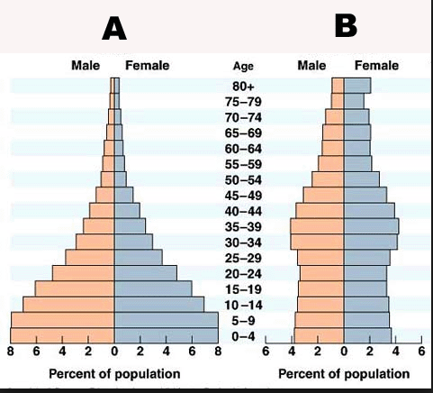

- For the population pyramids shown above, which shows rapid population growth? A Slow growth? B

- What is meant by Zero population growth?
The maintenance of a population at a constant level by limiting the number of live births to only what is needed to replace the existing population.

C
D
G
I
A
F
H
B
E
J
Look at the food web above, each letter represents an organism.
- Which organism(s) are the autotrophs? _F and J___________

- What organism(s) most likely get their energy from the sun? ____ F and J _____

- From which organism(s) does B get its energy? ______J and C____

- A mysterious virus kills all the J organisms in our ecosystem. How will this most likely affect the size of the population of organism A?
The population would be significantly reduced with the loss of this key producer and the energy it provided to the other organisms (feeding levels).

- Which organism(s) can act as primary (first) consumers? __A, G, I, B and C_____

- Explain how the energy from the sun gets passed to ALL ORGANISMS in the food web.
Light energy from the sun is converted to chemical energy (glucose and then ATP) in plants. Chemical energy in plants is then transferred to consumers and then by decomposers.

- Which trophic (feeding) level(s) could G be a part of? Check all that apply.
  - 1º (primary consumers)
  - 2º (secondary consumers)
  - 3º (tertiary consumers)
  - 4º (quaternary consumers)
- Define and provide an illustrative example of the following:
- Carnivore; Lion
- Herbivore: Gazelle
- Omnivore: Warthog/bear
- Decomposer: bacteria

- In your own words explain the difference between a producer and a consumer.
- Producers are autotrophs such as plants and algae that produce their own food. Consumers consume other organisms

